**Candidate Key**  
  
A candidate key is a combination of attributes that can be uniquely used to identify a database record without any extraneous data. Each table may have one or more candidate keys. In general, one of these candidate keys is selected as the table primary key.  
  
Example - From the above table EMPLOYEE_ID, EMPLOYEE_SSN_ID, and EMPLOYEE_DEPT_ID can be considered as candidate keys  
  
**Primary Key**  
  
A primary key is a single column or combination of columns that uniquely defines a record. None of the columns that are part of the primary key can contain a null value. A table can have only one primary key.  
  
Example - EMPLOYEE_ID or EMPLOYEE_SSN_ID can be considered as primary keys  
  
**Unique Key**  
  
A unique key or primary key [is a candidate key] to uniquely identify each row in a table. It may be comprised of either a single column or multiple columns.  
  
The major difference is that for unique keys the implicit NOT NULL constraint is not automatically enforced, while for primary keys it is enforced. Thus, the values in unique key columns may or may not be NULL.  
  
**Differences between Primary Key and Unique Key**

Primary Keys

1. It will not accept null values.         
2. There will be only one primary key in a table.         
3. Clustered index is created in Primary key.         
4. Primary key allows each row in a table to be uniquely identified and ensures that no duplicate rows exist.         
  
Unique Keys  
1. Null values are accepted.  
2. More than one unique key will be there in a table.  
3. Non-Clustered index is created in unique key.  
4. Unique key constraint is used to prevent the duplication of key values within the rows of a table and allow null values.  
  
**Alternate Key**

A candidate key that is not the primary key is called an alternate key.  
  
Example - If EMPLOYEE_ID is considered as primary keys then EMPLOYEE_SSN_ID is an alternate key.  
  
**Superkey**  
  
A superkey is a combination of attributes that can be uniquely used to identify a database record. A table might have many superkeys. Candidate keys are a special subset of superkeys that do not have any extraneous information in them.  
  
A primary key is therefore a minimum superkey.  
  
Examples - Any combination of the following can be considered as a Super key  
  
- EMPLOYEE_ID - Minimal Super Key  
- EMPLOYEE_ID and EMPLOYEE_SSN_ID  
- EMPLOYEE_ID, EMPLOYEE_SSN_ID and EMPLOYEE_DEPT_ID  
- EMPLOYEE_ID, EMPLOYEE_SSN_ID, EMPLOYEE_DEPT_ID, EMPLOYEE_FIRST_NAME  
- EMPLOYEE_SSN_ID, EMPLOYEE_FIRST_NAME, EMPLOYEE_LAST_NAME  
  
**Foreign Key**  
  
The foreign key identifies a column or a set of columns in one (referencing) table that refers to a column or set of columns in another (referenced) table.

**Composite Key**  
  
A primary key that made up of more than one attribute is known as a composite key.  
  
Example - [EMPLOYEE_ID and EMPLOYEE_SSN_ID] can together be treated as (one of) composite keys. Another combination can be [EMPLOYEE_ID, EMPLOYEE_SSN_ID and EMPLOYEE_DEPT_ID]  
  
**Surrogate Key**  
  
Surrogate keys are keys that have no business meaning and are solely used to identify a record in the table.  
  
Such keys are either database generated (example: Identity in SQL Server, Sequence in Oracle, Sequence/Identity in DB2 UDB etc.) or system generated values (like generated via a table in the schema).

Following demo shows the definition of Surrogate Key, Natural Key and Composite Key.

The INT IDENTITY is the favorite for surrogate key because it is automatic, fast (in indexes) and slim (4 bytes only). A natural key should have a unique constraint (if used as reference by Foreign Key) or unique index on it. When you are searching for a Primary Key candidate, ProductName and ProductNumber would become Candidate Keys since they are unique. ListPrice is not unique. If 2 or more columns are required to form a unique key, it is called Composite Key. ProductNumber & ListPrice is a Super Key, on the other hand ListPrice & Color is not a Super Key (not unique combination).

-- T-SQL demo of identity surrogate key and natural keys

USE tempdb;

GO

CREATE TABLE Product

(

ProductID int identity(1,1) primary key, -- surrogate key

ProductName varchar(50) unique, -- natural key

ProductNumber varchar(50), -- natural key

ListPrice money,

Color varchar(16),

ProductPrefix char(3),

ProductAbbrev char(10),

ModifiedDate datetime default (getdate()),

Constraint KeyPrefAbbrev unique (ProductPrefix,ProductAbbrev) -- composite key

);

GO

INSERT INTO Product (ProductName, ProductNumber, ListPrice, Color, ProductPrefix, ProductAbbrev)

SELECT Name, ProductNumber, ListPrice, Color, LEFT(ProductNumber, 3), RIGHT(ProductNumber, len(ProductNumber)-3)

FROM [AdventureWorks2014].Production.Product

GO

-- Put unique index on ProductNumber natural key

CREATE UNIQUE INDEX idxPrdctProdNum ON Product(ProductNumber);

SELECT * FROM Product ORDER BY ProductID;

GO

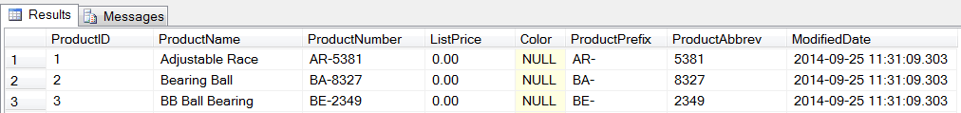



DROP TABLE tempdb.dbo.Product

A key is a single or combination of multiple fields in a table. It is used to fetch or retrieve records/data-rows from data table according to the condition/requirement. Keys are also used to create relationship among different database tables or views.

Types of SQL Keys

We have following types of keys in SQL which are used to fetch records from tables and to make relationship among tables or views.

1. Super Key

Super key is a set of one or more than one keys that can be used to identify a record uniquely in a table. Example: Primary key, Unique key, Alternate key are subset of Super Keys.

2. Candidate Key

A Candidate Key is a set of one or more fields/columns that can identify a record uniquely in a table. There can be multiple Candidate Keys in one table. Each Candidate Key can work as Primary Key.

3. Primary Key

Primary key is a set of one or more fields/columns of a table that uniquely identify a record in database table. It cannot accept null, duplicate values. Only one Candidate Key can be Primary Key.

4. Alternate key

An Alternate key is a key that can be work as a primary key. Basically it is a candidate key that currently is not primary key.

Example: In the following diagram RollNo and EnrollNo become Alternate Keys when we define ID as Primary Key.

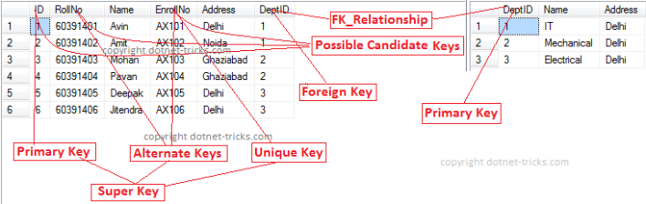

5. Composite/Compound Key

Composite Key is a combination of more than one fields/columns of a table. It can be a Candidate key, Primary key.

6. Unique Key

Unique Key is a set of one or more fields/columns of a table that uniquely identify a record in database table. It is like Primary key but it can accept only one null value and it cannot have duplicate values. For more help refer the article Difference between primary key and unique key.

7. Foreign Key

Foreign Key is a field in database table that is Primary key in another table. It can accept multiple null, duplicate values.

Example: We can have a DeptID column in the Employee table which is pointing to DeptID column in a department table where it a primary key.